

**B.Tech(CSE) Semester – III**

**Summer Internship (Community Service)**

Phase-1 Report

Name: SWEKIT PATEL

Roll No: 22BCE347

Division: F-1

**Organization details**

• **Name of the Organisation**: Karmavir Charitable Trust

• **Name of the contact person**: Aditya Raval

• **Address:** Reg No. F/21602/,217, Samaan Complex, Mansi Circle, Satellite

• **Telephone:** +91 8160536889

• **Email:** karmavircharitabletrustkarmavi@gmail.com

• **Major activities:**

1. Tree plantation drive and awareness.
2. Distributing clothes to needy people
3. Book donation and interacting with children
4. Food for animal
5. Donating food supplies to needy people in the neighborhoods

• **Time duration**: 04/07/2023 - 14/07/2023 (22 to 24 hours of work)

• **Location of activities**: Ahmedabad

**Activity 1: Tree Plantation Drive**

Day 1 (4 July 2023)

* On day 1, we were introduced to the NGO's mission and all the work it dedicated to the betterment of society.
* We had an inspiring interaction with Aditya Raval and Falak Raval. They manage the Karmavir NGO.
* Late in the day, we actively participated in a tree plantation drive at a nearby community.
* Following the plantation drive, we also designed a poster aimed at raising awareness about the importance of tree plantation.

**Activity 2: Donated used old clothes**

Day 2 (5 July 2023)

* On day 2, we visited various households door-to-door and collected old clothes. We covered approximately 25 houses during this initiative.
* Numerous team members gathered clothing donations from various locations and contributed them to the NGO's collection point.
* Subsequently, we cleaned and organized these donated clothes, getting them ready for distribution on the following day.

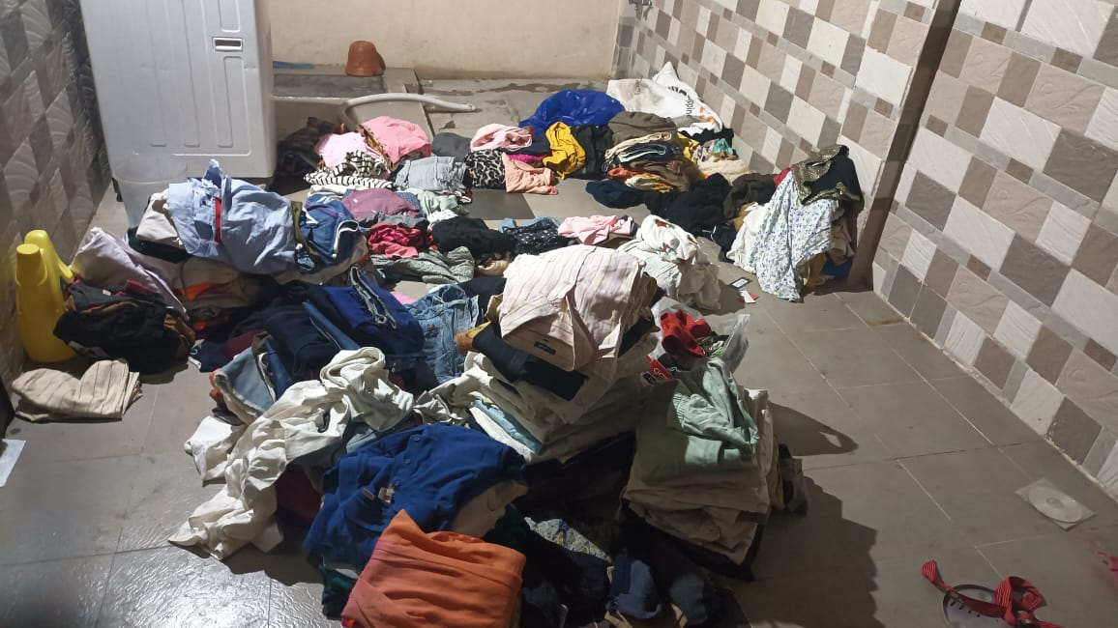

Day 3 (6 July 2023)

* On day 3, we formed small teams and started distributing of clothes we collected the preceding day to the poor people.
* During the clothing distribution, we took the opportunity to engage with these individuals and gain insights into their way of life.
* Giving out clothes to people according to size was definitely a difficult task as so many people were present at the location.

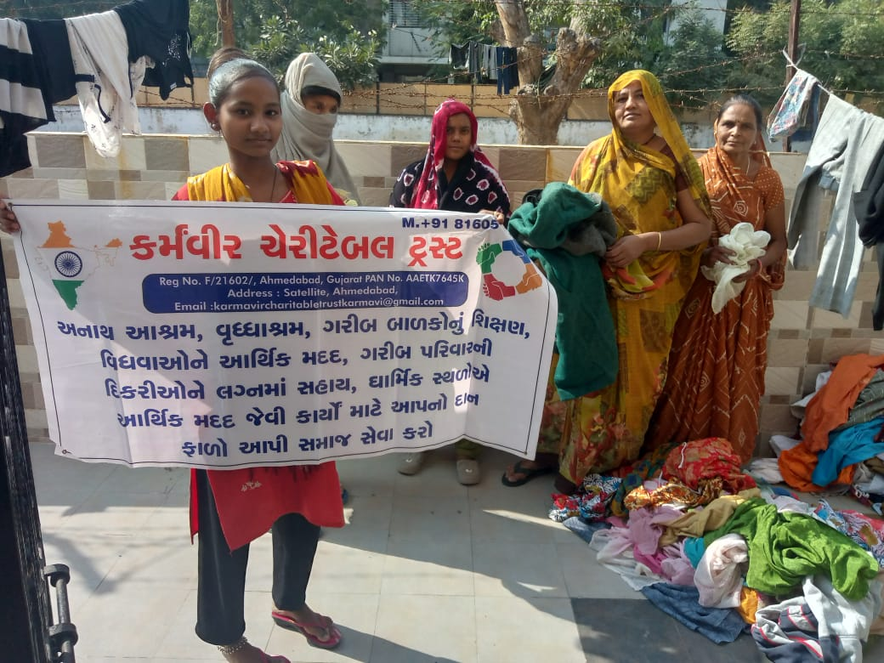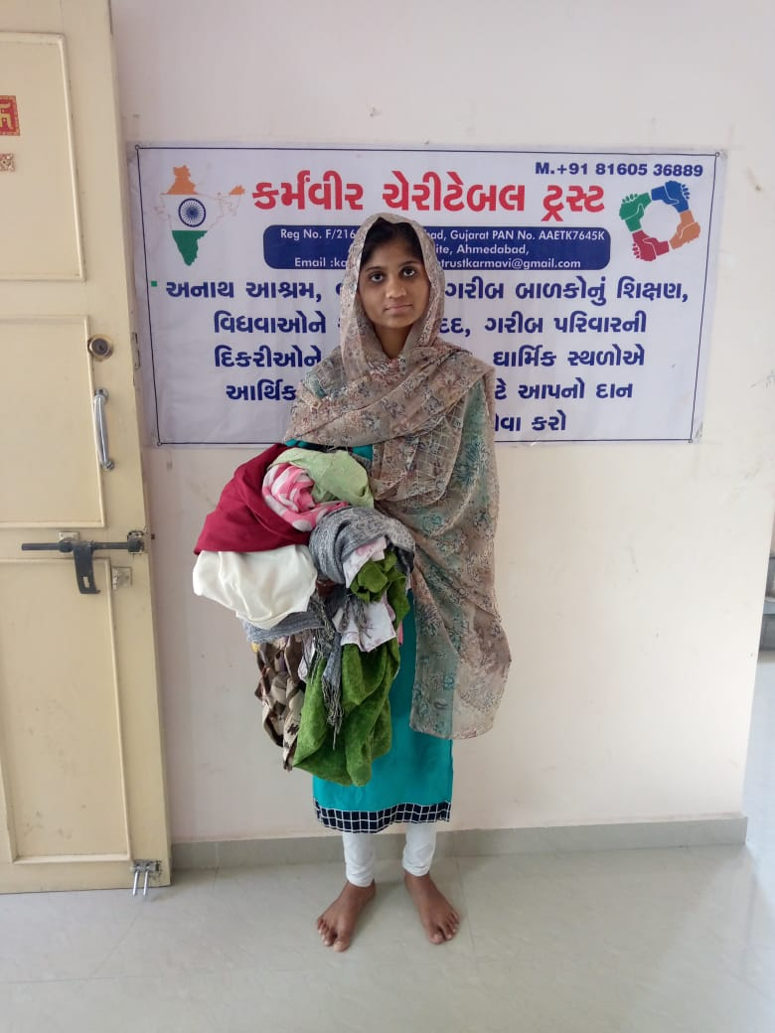

**Activity 3: Donating books and stationery**

Day 4 (7 July 2023)

* On day 4, our NGO Karmavir requested us to contribute books to a library that would directly benefit underprivileged individuals.
* In response, I gathered the books I wished to donate from my own collection at home.
* Several of my friends as well as other members donated books and stationery.
* In total, we collected over 120 books, and textbooks and also collected basic stationery which we donated to small children.

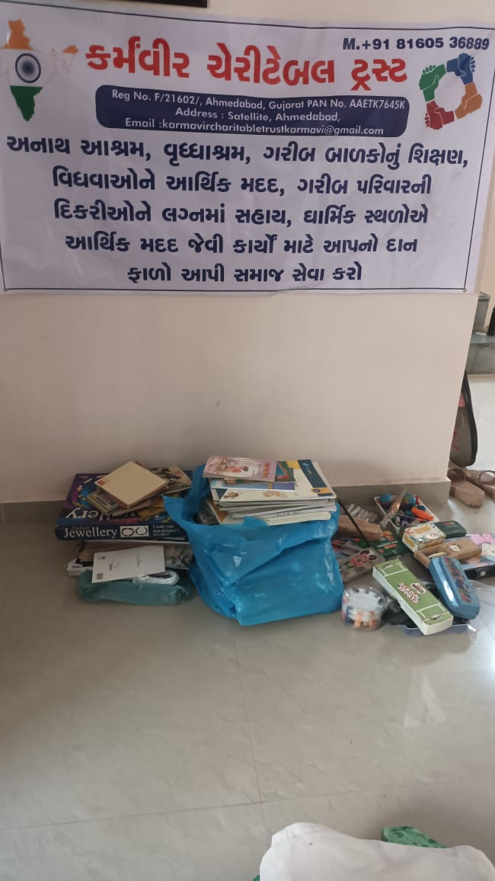



**Activity 4: Preparing food for needy people**

Day 5 (8 July 2023)

* On day 5, I was assigned the task of buying supplies for preparing lunch for poor people living in a community.
* Supplies included vegetables, rice, dal, sunflower oil, spices, and wheat flour.
* Lunch was prepared the next day.

Day 6 (9 July 2023)

* On day 6, our NGO Karmavir prepared food for needy people.
* Food prepared included Sabzi, Roti, Dal, and Rice.
* We were asked to help other members with the distribution and packaging.
* I was personally assigned the task of packing and loading the food prepared.
* Each and every task whether it is small or big helps us to learn something new every day in life.

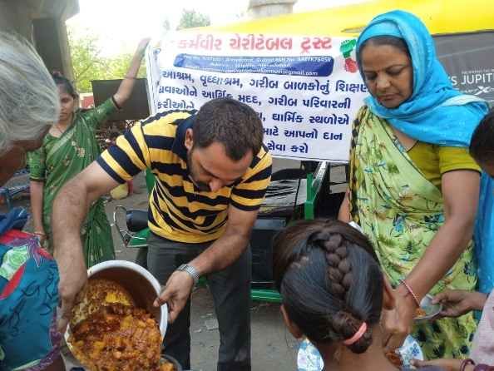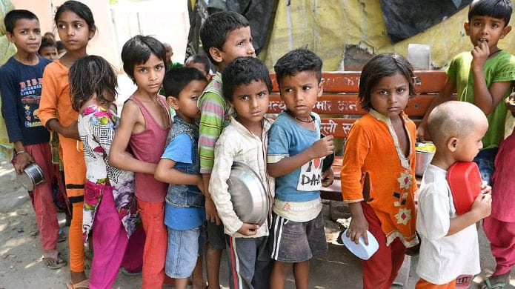

**Activities 5: Feeding cow and cleaning the ground**

Day 7 (10 July 2023)

* On day 7, we bought fruits from a wholesale dealer in bulk.
* These fruits were intended to be used as feed for the cows at a nearby cattle farm.
* There are approximately 30 to 50 cows in that cow shelter.
* It holds immense significance to ensure the well-being of the cows by providing them with proper nourishment, free from plastic waste contamination.

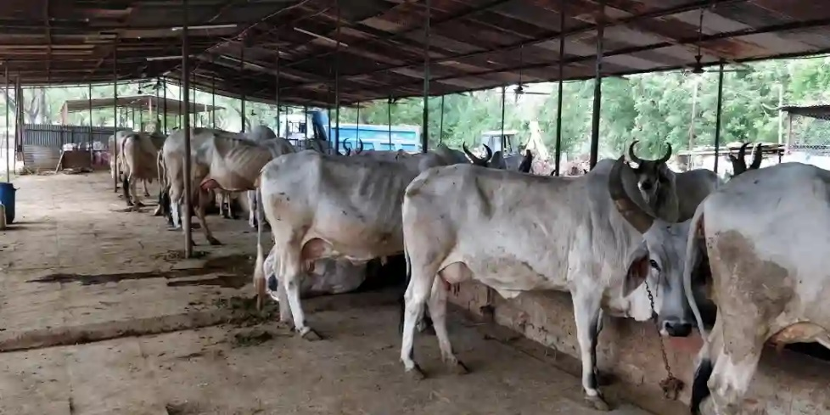

Photo: Sola Bhagwat Vidhyapith Mandir

Day 8 (11 July 2023)

* On day 8, I took part in a cleanliness drive organized by Karmavir NGO.
* My specific assignment involved cleaning a playground that had become strewn with plastic waste primarily from food packaging.
* Approximately 12 individuals came together to contribute to this impactful cleanliness initiative.

**Activity 6: Donated essentials to beggars in the community**

Day 9 (12 July 2023)

* On Day 9, we procured essential items such as toothpaste, soap, hair oil, utensils, flour, and various other necessities from a shop affiliated with an NGO.
* Our purpose was to distribute these items to the beggars on the streets, aiming to provide them with basic essentials for their daily lives.
* With the collective efforts of our team, we aimed to make a positive impact on the lives of those less fortunate.

Day 10 (14 July 2023)

* On the last day, I thoroughly examined all my previous assignments and documented a few additional points.
* Collaborating with my friends, we interacted with individuals employed at the NGO.
* Interacting with employees helped us to understand their motive to work in the NGO.
* I completed various document and form-filling tasks as part of the final stages of our social work internship.
* Lastly, I collected my certificate.

**Beneficiaries of Activity from Community/City/Village**: Thaltej, Science City, Bodekdev, and several other communities in Ahmedabad

**Identification of the problems associated with the concerned community/NGO:**

There were several problems associated with the community:

* Lack of education among people.
* Less availability of skilled labour hence they were not able to get high-paying jobs.
* Unhygienic living conditions which caused several problems.
* More people I interacted with were beggars and earned a living by begging. Some were not willing to work citing health and other problems.
* These communities work by several NGOs around the country and able to provide help like lunch, dinner, clothes, books, etc. are for a short period of time. Hence no permanent solution is there.

**Technical Solution proposed:**

* Talking about a permanent solution increase in manufacturing companies and an increase in the number of businesses in the country is the only possible solution.
* And short-term solutions include the work of NGOs and other institutions.
* Another solution for healthcare is a national database of each and every person and using that data for prediction of the spread of disease at a particular time in a particular area. It can be beneficial for the government to help people efficiently.

**Impact of Activity for Societal Benefit:**

* Our work definitely helped needy people in Ahmedabad and we continue to serve needy people.
* These work despite being small can help communities and reduce their stress for a day or two.
* Helping children can help parents and encourage them to send their children to school.
* These mid-day meals provided by NGOs can help beggars.
* Providing rations to needy people helps them save their monthly food money.

**Concluding Remarks:**

Our NGO's dedicated efforts continue to drive positive change. With unwavering commitment, we stride forward, empowered by the impact we've achieved and inspired by the challenges that lie ahead. Together, we shape a brighter future for all.

**Certificate:**

